Sb₂Se₃ single-layer 1064nm-optical limiter at 1.5 Million Cycles
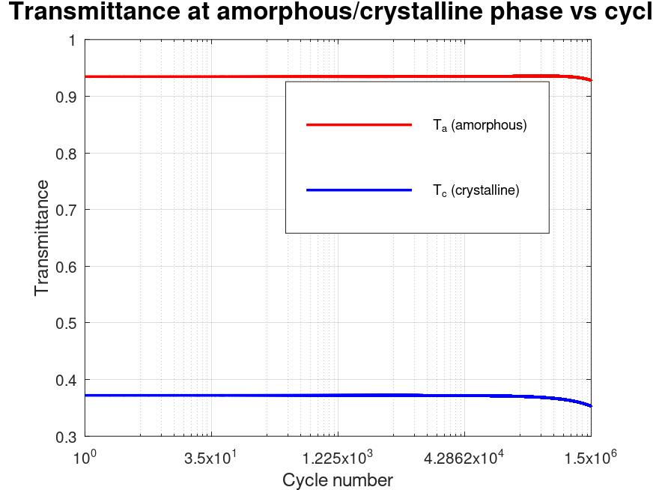 | 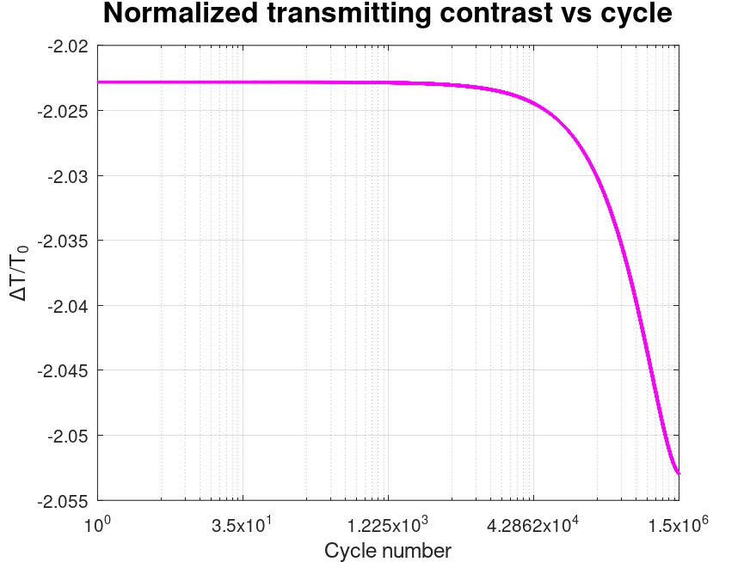
(a) | (b)
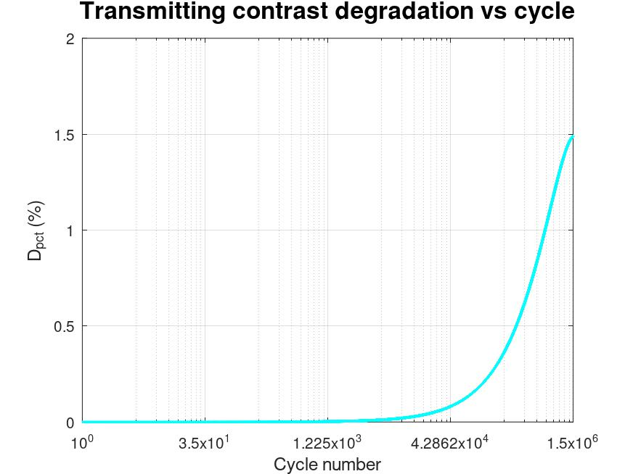 | 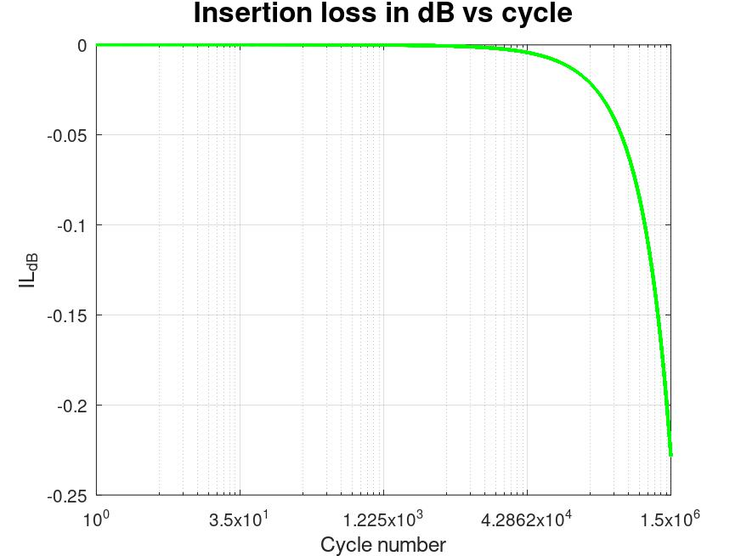
(c) | (d)
Figure X. Endurance performance of the single-layer Sb₂Se₃ resonant optical limiter at 1064 nm after 1.5×10⁶ thermo-optical cycles. (a) On-resonance transmittance of the device when Sb₂Se₃ is in the amorphous and crystalline states as a function of cycle number. (b) Normalized transmitting contrast, ∆T/T₀, versus cycle number, referenced to the initial contrast at the first cycle. (c) Percentage transmitting-contrast degradation relative to the initial value as a function of cycle number. (d) Insertion loss in the high-transmission (amorphous) state, expressed in dB, as a function of cycle number.

Sb₂Se₃/TiO₂ bilayers 1064nm-optical limiter at 1.5 Million Cycles
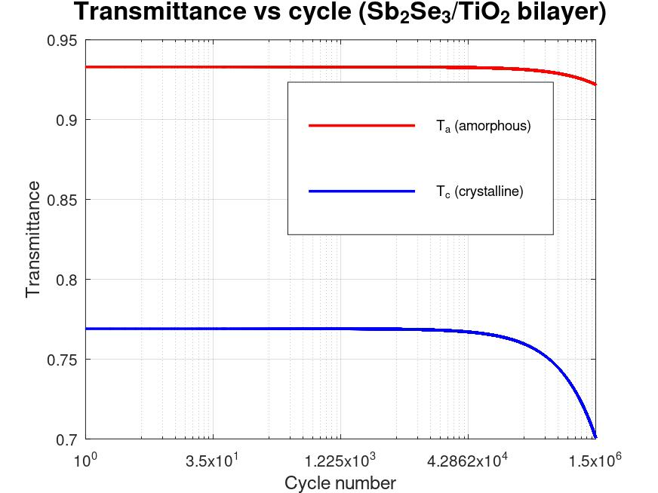 | 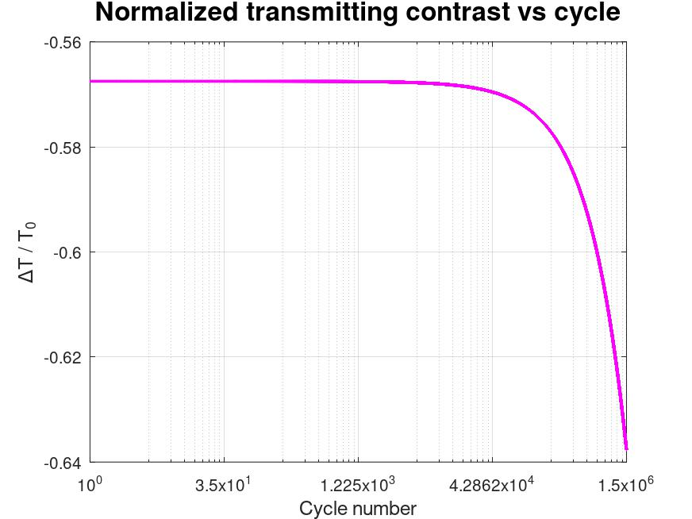
(a) | (b)
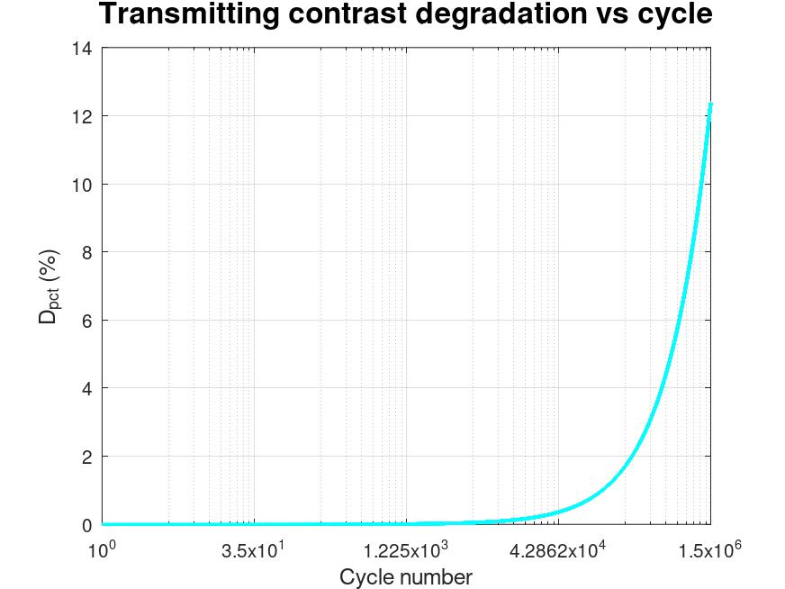 | 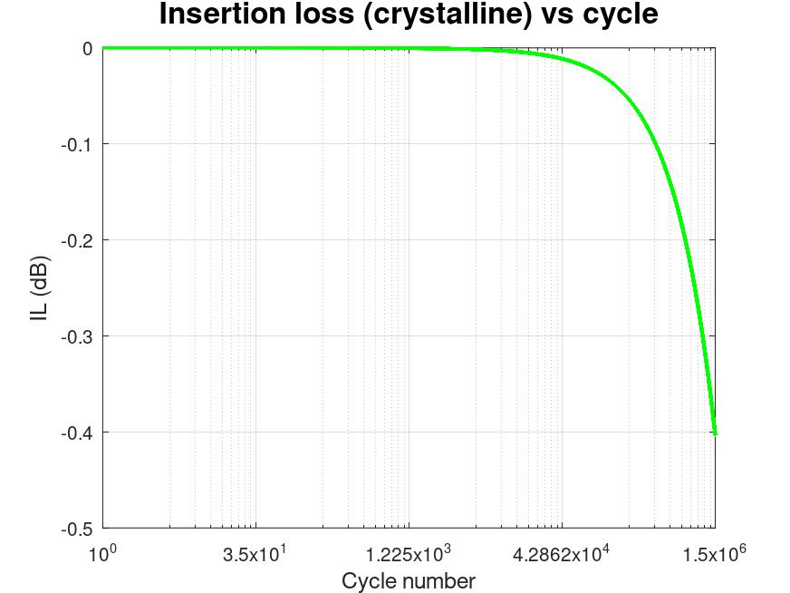
(c) | (d)
Figure Y. Endurance performance of the Sb₂Se₃/TiO₂ bilayer resonant optical limiter at 1064 nm after 1.5×10⁶ thermo-optical cycles. (a) On-resonance transmittance of the device when Sb₂Se₃ is in the amorphous and crystalline states as a function of cycle number. (b) Normalized transmitting contrast, ∆T/T₀, versus cycle number, referenced to the initial contrast at the first cycle. (c) Percentage transmitting-contrast degradation relative to the initial value as a function of cycle number. (d) Insertion loss in the high-transmission (amorphous) state, expressed in dB, as a function of cycle number.

[(Sb₂Se₃)/2|MgF₂|(Sb₂Se₃)/2]⁵ 1064nm-optical limiter
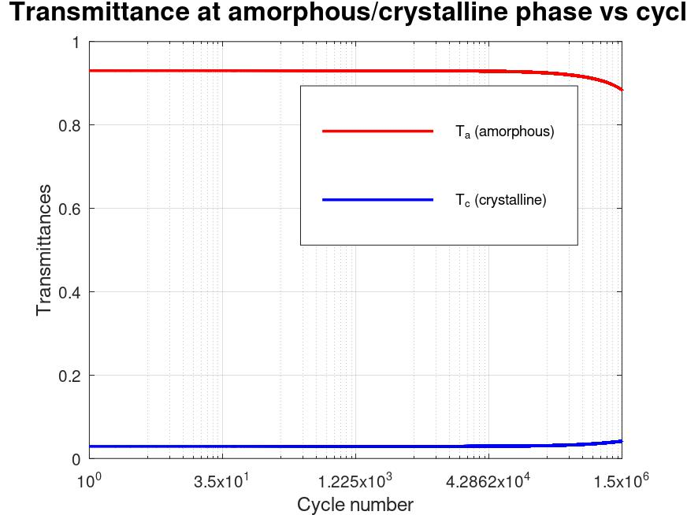 | 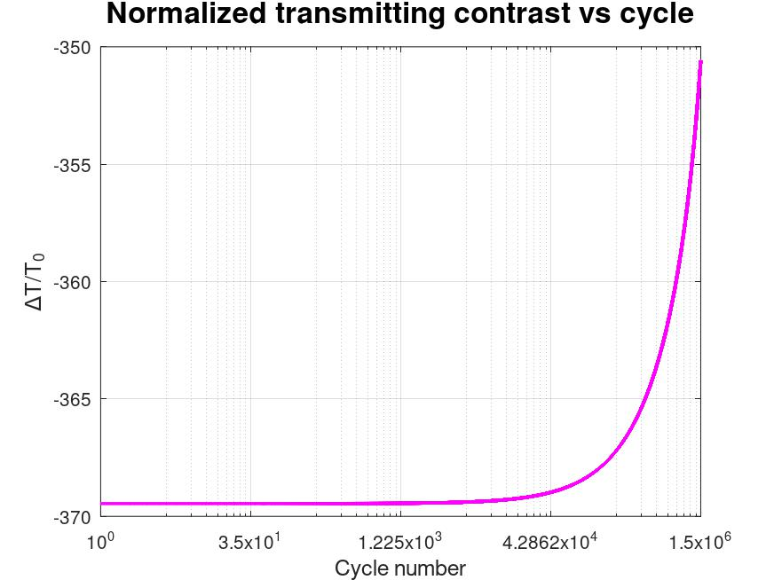
(a) | (b)
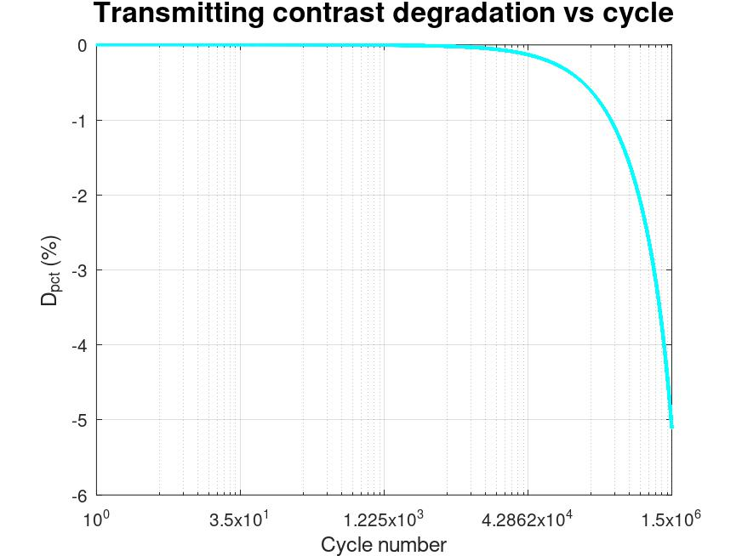 | 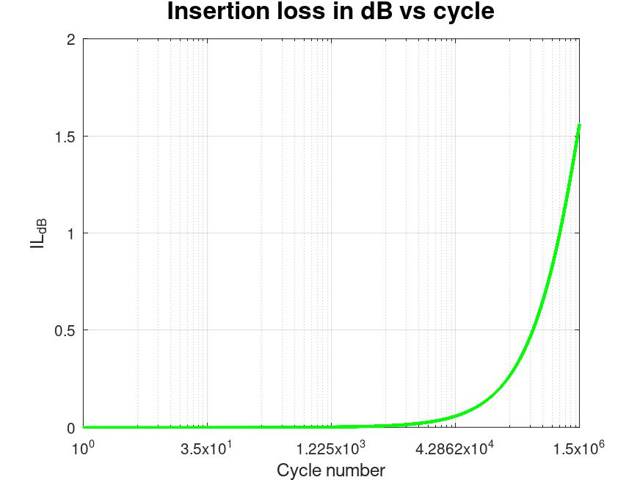
(c) | (d)
Figure Z. Endurance performance of the 11-layers-edge-filter resonant optical limiter at 1064 nm after 1.5×10⁶ thermo-optical cycles. (a) On-resonance transmittance of the device when Sb₂Se₃ is in the amorphous and crystalline states as a function of cycle number. (b) Normalized transmitting contrast, ∆T/T₀, versus cycle number, referenced to the initial contrast at the first cycle. (c) Percentage transmitting-contrast degradation relative to the initial value as a function of cycle number. (d) Insertion loss in the high-transmission (amorphous) state, expressed in dB, as a function of cycle number.

Endurance testing at 1064 nm, as shown in figure X-Z, confirms that all three resonant optical limiter designs, single Sb₂Se₃ layer, Sb₂Se₃/TiO₂ bilayer, and 11-layers-edge-filter cavity, remain functional up to 1.5×10⁶ thermo-optical cycles, with gradual but design-dependent degradation of their key figures of merit.
For the single‑layer limiter, the amorphous‑state transmittance stays high and nearly constant over most of the cycling window, whereas the crystalline‑state transmittance slowly increases with cycle number, indicating a reduction of effective phase contrast in the film. The addition of a TiO₂ layer slightly modifies the absolute transmittance levels but preserves the same qualitative trend of stable high‑transmission amorphous state and slowly brightening crystalline state. In the 11-layers-edge-filter cavity, both states show more pronounced evolution because the resonance is more sensitive to small index drifts, yet the device still maintains a clear separation between amorphous and crystalline transmission after 1.5×10⁶ cycles.
The normalized contrast, defined from the difference between amorphous and crystalline transmittances and referenced to the initial value, decreases monotonically with cycle number for all structures. The single-layer design exhibits the slowest contrast decay, consistent with its simpler interference condition and weaker field enhancement. In contrast, the multilayer cavity shows a faster reduction of normalized contrast, reflecting the stronger dependence of the resonant line shape on endurance-induced changes in the Sb₂Se₃ refractive index and loss.
When the contrast change is expressed as percentage degradation relative to the first cycle, all devices show only modest loss at low cycle counts and a more rapid decline as the test approaches 1.5×10⁶ cycles. The bilayer and edge-filetr cavity structures display larger percentage degradation than the single-layer limiter, which indicates that while resonant enhancement improves low-cycle performance, it also amplifies the impact of long-term drift in the phase-change material.
The insertion loss in the high-transmission (amorphous) state increases gradually with cycling for every structure, reflecting the small but cumulative rise in absorption and scattering within Sb₂Se₃. However, the overall insertion loss after 1.5×10⁶ cycles remains within acceptable limits for 1064 nm operation, especially for the single-layer and bilayer designs, implying that endurance-induced losses do not fully compromise the limiter performance over the targeted lifetime.

